1.5 Project
Inheritance, Composition, and User Interactions

Aubrey D. Soule
IT, Software Development and Coding, ECPI University
SDC330: Advanced Programming Using Java
Dr. Helio Castro
April 7, 2026

The Gundam Rolodex
- When the application starts, what will the user see?
  - Welcome to Gundam Rolodex
  - Gundam quote – “War is not about who is right, but who is left.”
  - Overview of the rolodex
  - Instructions – choose an option:
    - 1. Add Gundam
    - 2. View All Gundam
    - 3. Update Gundam
    - 4. Delete Gundam
    - 5. Exit
- How will the user make selections for what to do?
  - Adding information
    - Gundam Name
    - Model Number
    - Pilot
    - Series
    - Type
  - Displaying information
    - Displays all Gundam Info
  - Updating information
    - Choose Gundam
    - Edit Fields
  - Deleting information
    - Enter Gundam name or Index to delete
- How will you format the display of the output?
  - List of all the information
- How will the user exit the application?
  - Enter #5 to exit
  - Display exit message
    - “Thank you for using Gundam Rolodex”
- Inheritance (Base Class)
  - Class: Gundam
  - Name
  - Model Number
  - Pilot

- Inheritance (Derived Class)
  - Class: Combat Gundam extends Gundam
  - Type
  - Weapon

- Composition Class
  - Class: Manufacturer
  - Name
  - Origin

Screenshot
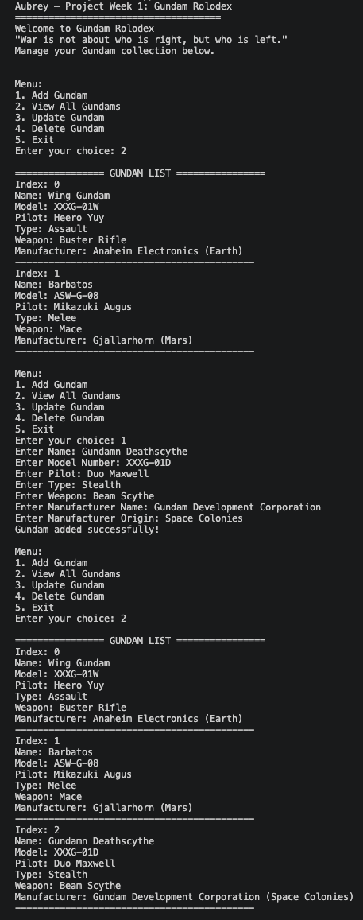
References

